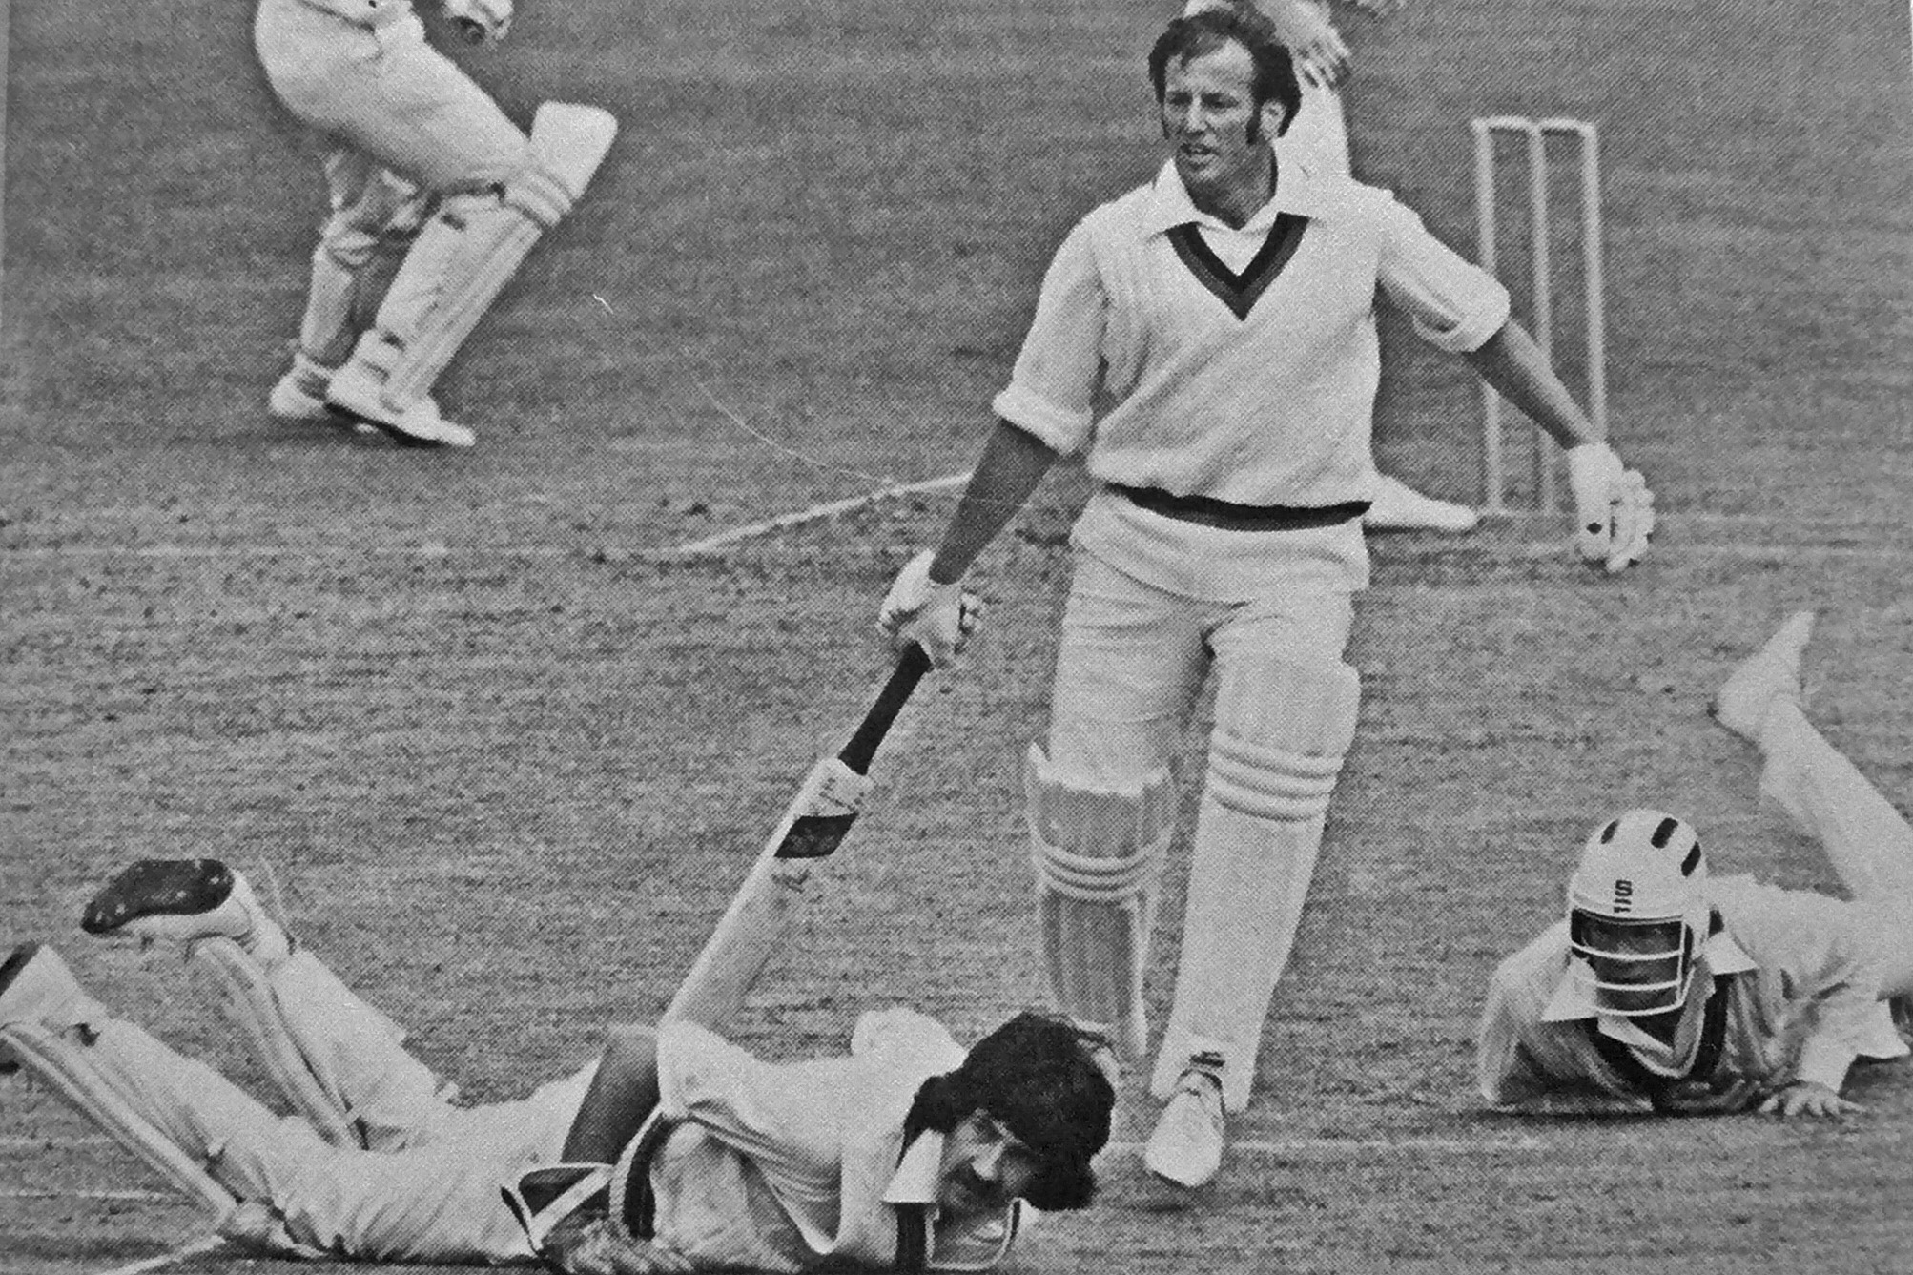

**David Stead runs through as keeper Warren Lees and Stu McCallum fail to stop the ball.**

**Canterbury v Otago 14 January 1978 Lancaster Park**

**Otago 253/7 declared and 145. Canterbury 200/7 declared and 202/8. Canterbury won by two wickets.**